CHILDHOOD ANEMIA IN NIGERIA: WHAT CAN THE DATA TELL US?
A STATISTICAL AND MACHINE LEARNING ANALYSIS OF SOCIO ECONOMIC AND DEMOGRAPHIC FACTORS AMONG CHILDREN IN NIGERIA

Abstract
Childhood anemia remains an important public health concern, particularly in settings where socioeconomic and geographic conditions vary widely. In this project, I used data from the 2024 Demographic and Health Survey (DHS) to examine patterns of anemia among children in Nigeria and explore whether selected demographic, socioeconomic and behavioral characteristics could predict anemia status.
The dataset contained 27,783 child records, of which 11,053 had available anemia measurements. Among the tested children, 47.7% were classified as anemic. Anemia prevalence varied across wealth groups, geographic zones and place of residence. Wealth and geographic zone showed statistically significant associations with anemia, while recent fever history, household bed-net ownership and child bed-net use did not show statistically significant associations in this analysis.
I also compared Logistic Regression and Random Forest models. Both models produced limited predictive performance, with AUC values of approximately 0.56 and 0.57 respectively.
The findings show an important distinction between identifying factors associated with anemia at the population level and accurately predicting anemia in individual children.

Background Study
1. Introduction
Anemia in childhood is more than a laboratory measurement. It can affect a child's health, development and ability to thrive. Understanding which groups experience higher levels of anemia can help researchers and public health practitioners identify areas that deserve closer attention.
Nigeria is a useful setting for this kind of analysis because children's living conditions differ considerably across geographic regions, socioeconomic groups and urban and rural communities.
In this project, I wanted to go beyond simply calculating an anemia rate. I asked two related questions:
Which characteristics are associated with childhood anemia, and can those characteristics be used to predict which individual children are likely to be anemic?
To answer these questions, I combined descriptive analysis, statistical testing and machine learning.
2. Study Aim
The aim of this analysis was to examine the distribution of childhood anemia in Nigeria and investigate whether selected socioeconomic, geographic, demographic and behavioral characteristics were associated with anemia and could predict individual anemia status.
Objectives
The analysis sought to:
1. Estimate the observed prevalence of anemia among children with available anemia measurements.
2. Examine anemia prevalence across household wealth groups.
3. Compare anemia prevalence across geographic zones and urban/rural residence.
4. Examine associations between anemia and selected behavioral variables.
5. Build classification models for predicting anemia status.
6. Compare the performance of Logistic Regression and Random Forest.

3. Data and Methods
The analysis used data from the 2024 Demographic and Health Survey (DHS)
The dataset contained 27,783 child records. Anemia status was available for 11,053 children, and these children formed the analytical sample for the main anemia analysis.
Anemia was converted into a binary outcome:
0: Not anemic
1: Anemic (mild, moderate or severe)
The analysis considered the following predictors:
- Geographic zone
- Household wealth index
- Urban/rural residence
- Recent fever history
- Household bed-net ownership
- Child bed-net use
- Birth order

For the statistical analysis, I used chi-square tests to examine associations between anemia status and selected categorical variables.
For the machine learning component, I trained two classification models:
- Logistic Regression
- Random Forest
Categorical variables were one-hot encoded using a preprocessing pipeline. The data were divided into 80% training and 20% testing sets using stratification.
Model performance was assessed using accuracy, precision, recall, F1-score, confusion matrices and ROC-AUC.

4. Results
4.1 Almost half of the tested children were anemic
Among the 11,053 children with available anemia measurements, 47.7% were classified as anemic.
This figure describes the children with available anemia measurements in the dataset and should not be interpreted as the prevalence among all children represented in the original dataset.
4.2 Wealth was associated with anemia
Anemia prevalence differed across household wealth groups.

Wealth group Observed anemia prevalence
Poorest 49.2%
Poorer 50.9%
Middle 48.5%
Richer 47.9%
Richest 41.1%

The chi-square test showed a statistically significant association between wealth group and anemia status (p < 0.001).
The richest group had the lowest observed anemia prevalence, while the poorer groups had higher observed prevalence.

Figure 1. Observed anemia prevalence by household wealth
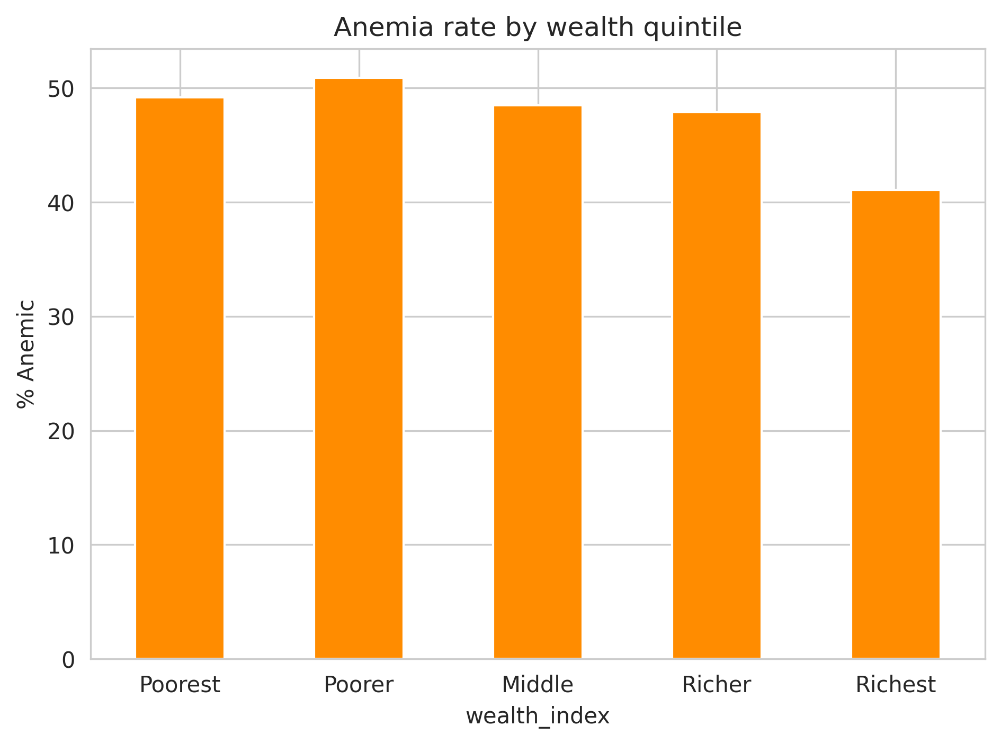
The pattern is interesting, but it does not tell us why the differences exist. This analysis identifies an association; it does not establish that household wealth itself causes anemia.
4.3 Geographic differences were also observed
Anemia prevalence varied across Nigeria's geographic zones.
Geographic zone Observed anemia prevalence
North Central 43.6%
North East 49.0%
North West 46.2%
South East 54.0%
South South 46.9%
South West 46.7%

The association between geographic zone and anemia was statistically significant (p < 0.001).
The South East had the highest observed prevalence at 54.0% among the zones examined.

Figure 2. Observed anemia prevalence by geographic zone

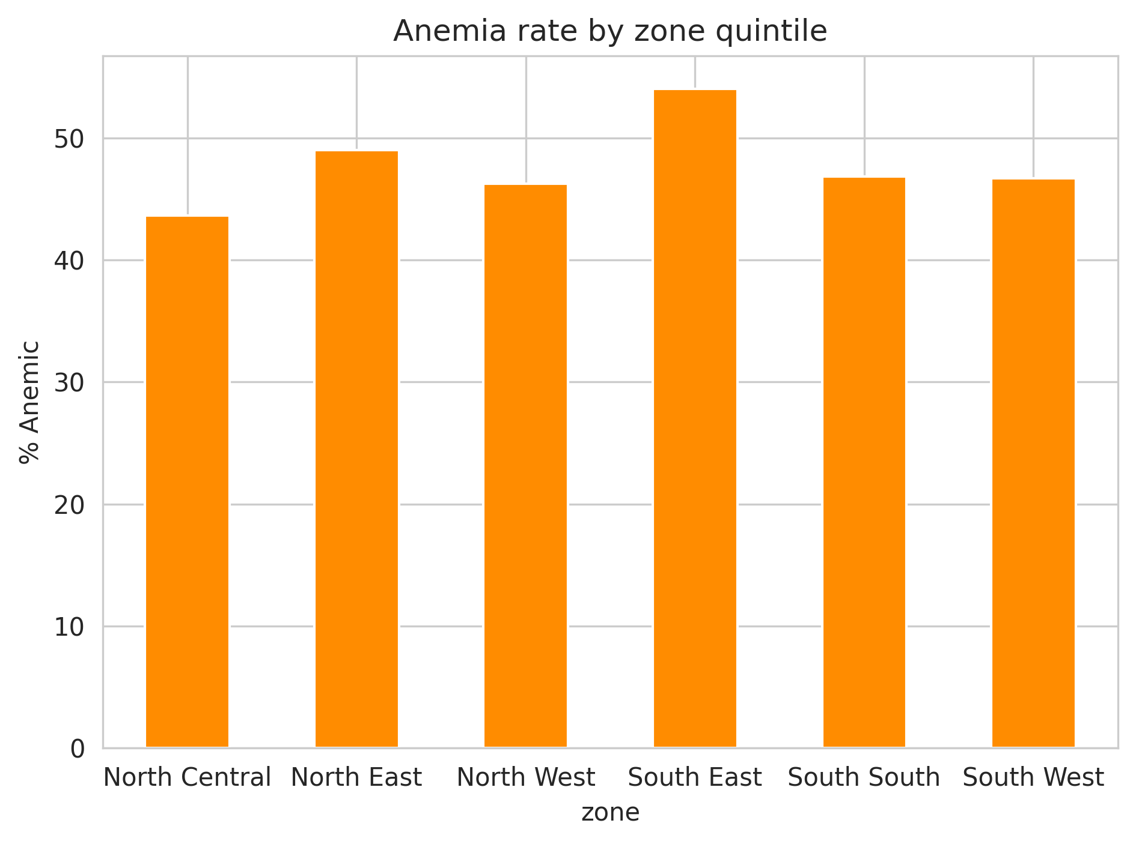
Geography appears to matter, but the analysis does not tell us which factors within each region are responsible for the differences.
4.4 Rural children had higher observed anemia prevalence
The analysis also showed a difference between urban and rural children.
Urban: 45.2%
Rural: 49.4%

The association between residence and anemia was statistically significant.

Figure 3. Observed anemia prevalence by place of residence
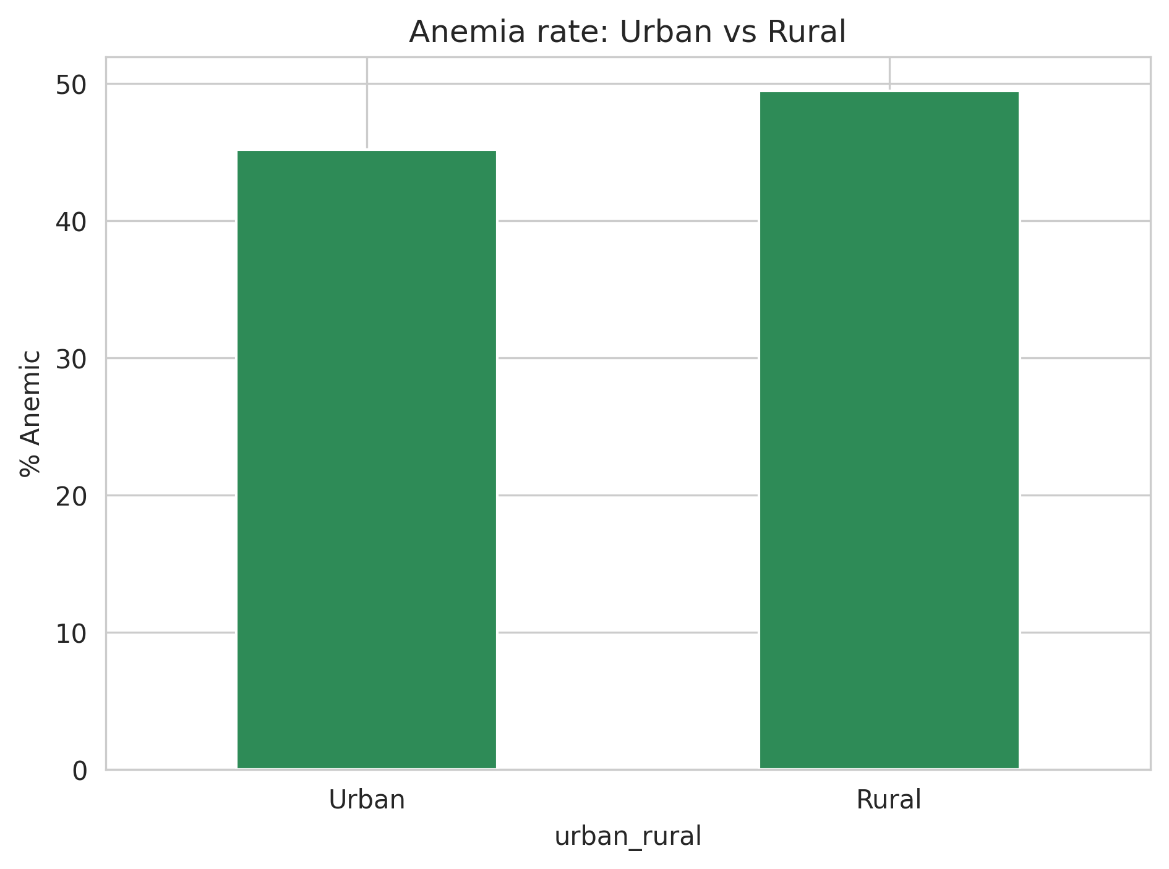
The difference is relatively modest, but it raises an important question: do socioeconomic conditions have the same relationship with anemia in urban and rural settings?
4.5 Bed-net use and recent fever did not show significant associations
Household bed-net ownership and child bed-net use were examined because of their relevance to malaria prevention.
However, neither household net ownership nor child net use showed a statistically significant association with anemia in this analysis.
Recent fever history was also not significantly associated with anemia.
Bed-net use and recent fever are indirect indicators and do not establish whether a child had malaria or another infection that could contribute to anemia.
5. Can Machine Learning Predict Anemia?
This was the part of the analysis I found particularly interesting.
It is easy to find variables that are statistically associated with an outcome. The harder question is whether those variables contain enough information to correctly identify individuals.
I therefore trained two classification models.
Logistic Regression
Logistic Regression was used as an interpretable baseline model.
Random Forest
Random Forest was used as a more flexible model that can capture nonlinear relationships between predictors.
The results were:
Model Accuracy AUC
Logistic Regression ~54% 0.56
Random Forest ~54% 0.57

Figure 4. ROC curve comparison
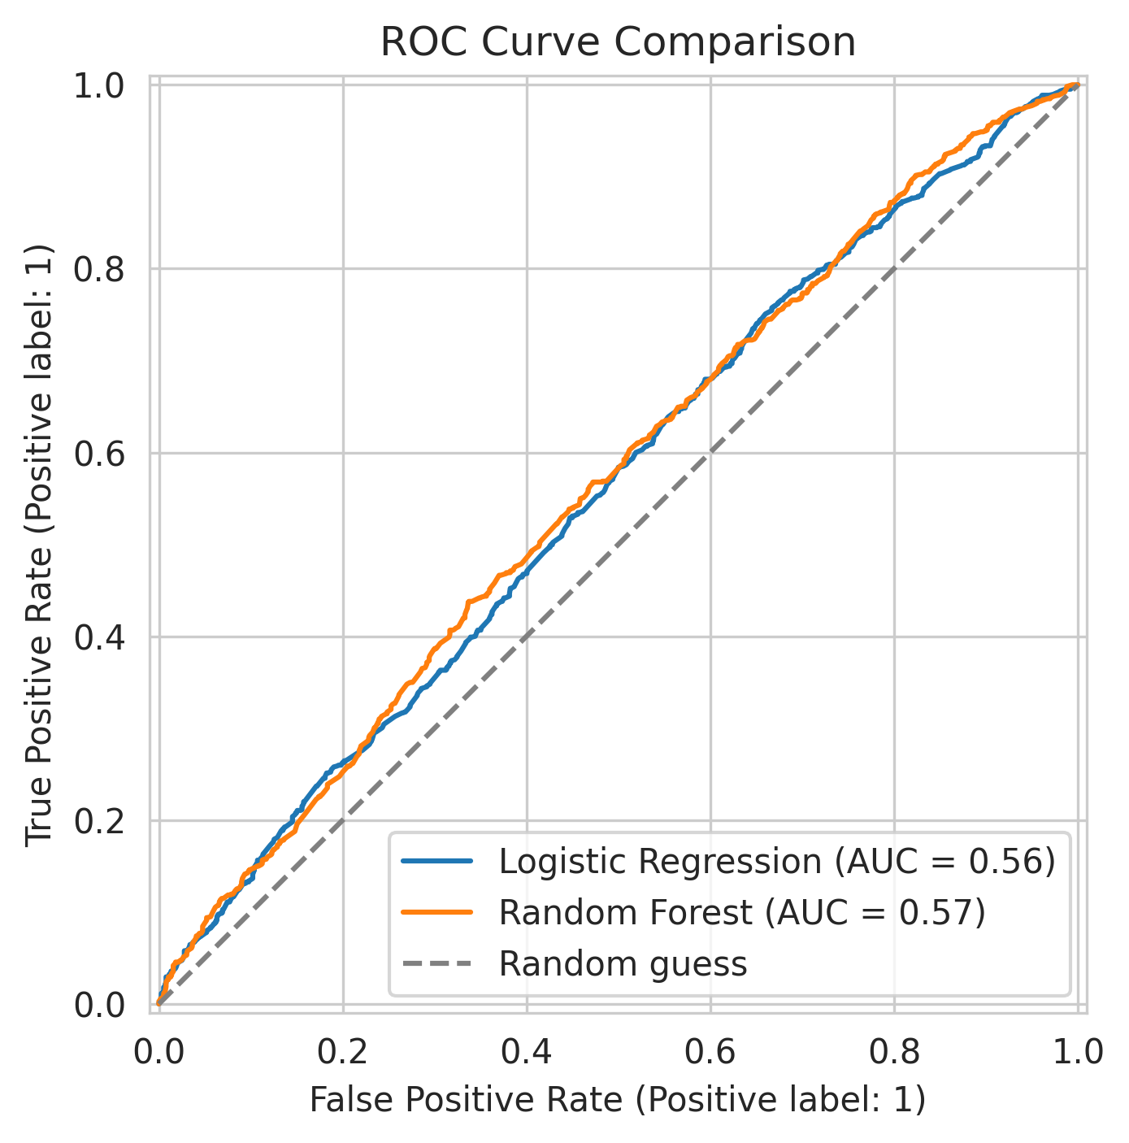
Both ROC curves remained close to the diagonal line representing random classification.
This means that the models performed only slightly better than chance.
The Logistic Regression model also identified only about 26% of the children who were actually anemic in the test set.
6. An Important Lesson from the Model
The analysis showed that wealth and geographic zone were statistically associated with anemia, but those variables were still not strong enough to accurately predict anemia at the individual level.
That distinction matters.
A factor can be associated with an outcome across a population without being useful enough to predict what will happen to a particular individual.
In this case, knowing a child's geographic zone, wealth group, residence and selected behavioral characteristics was not enough to reliably determine whether that child was anemic.
This suggests that important information needed for individual prediction may be missing from the selected variables.
7. What Did the Random Forest Find?
The Random Forest feature-importance analysis placed South East geographic category, the richest wealth category and birth order among the leading features influencing its predictions.

Figure 5. Leading Random Forest features

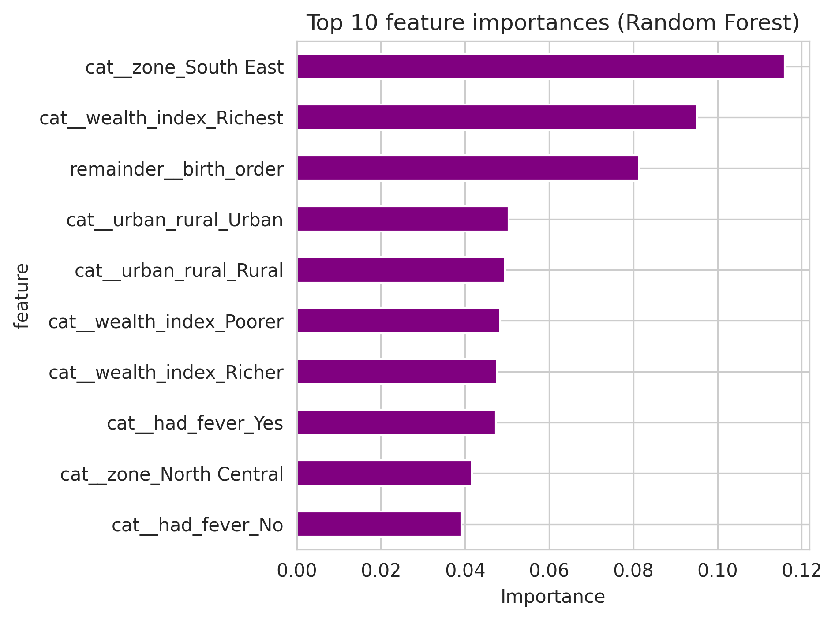

Interestingly, geographic zone and wealth were also among the variables that showed statistically significant associations with anemia during the earlier analysis.
However, feature importance should not be interpreted as proof that these characteristics cause anemia.
8. Does Wealth Have the Same Relationship with Anemia Everywhere?
I also explored the relationship between wealth and residence.
The analysis suggested that the difference between urban and rural children was **not constant across wealth groups.

Figure 6. Anemia prevalence by wealth group and residence
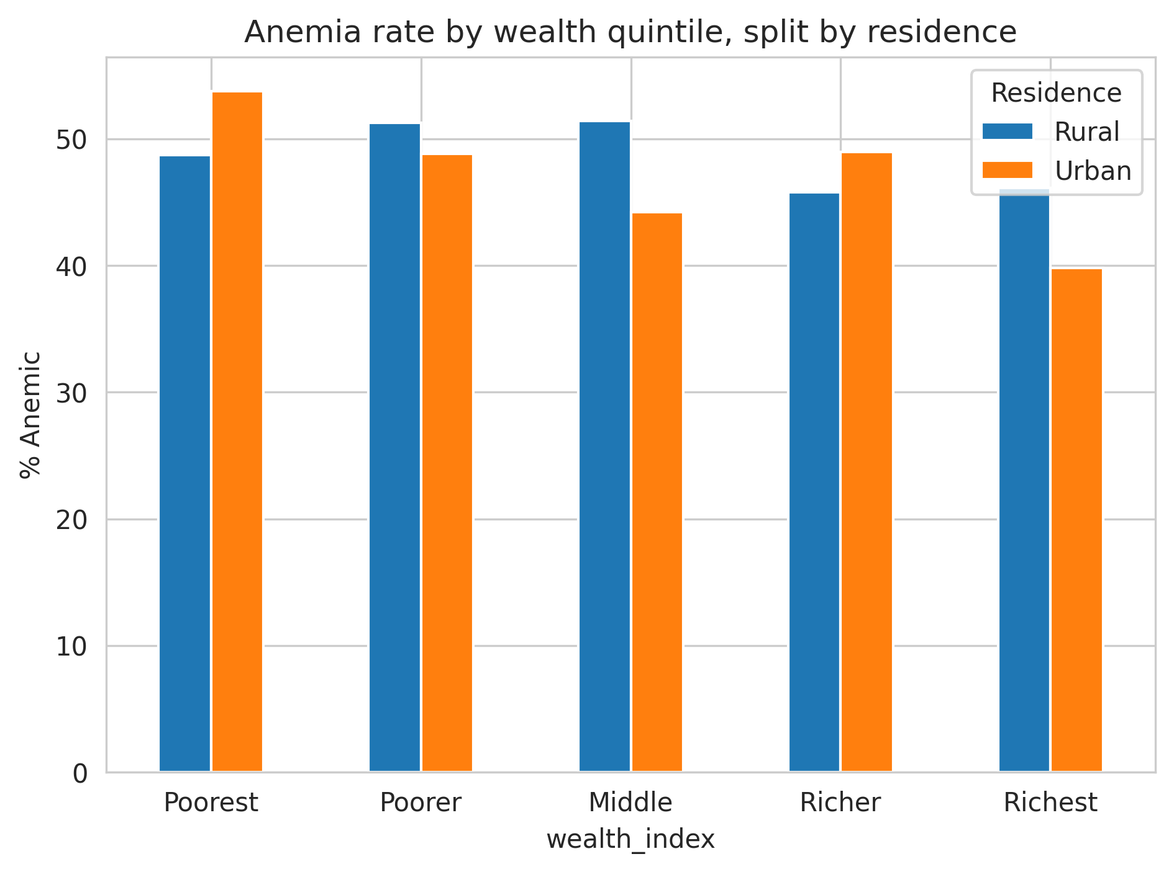
0- -This suggests that wealth and residence may not operate independently.
However, this was an exploratory analysis. A formal interaction model would be needed to determine whether the interaction is statistically supported.
9. What I Learned from the Analysis
Three findings stood out to me.
First, socioeconomic differences were visible.
Anemia prevalence was not evenly distributed across wealth groups.
Second, geography mattered.
The observed prevalence differed considerably between geographic zones, with the South East recording the highest rate in this analysis.
Third, association did not equal prediction.
The variables that showed population-level relationships with anemia did not produce a strong individual-level prediction model.
For me, this was one of the most useful lessons from the project. A model does not become valuable simply because it produces predictions. Its performance has to be tested, and sometimes the result tells us that the available information is not enough.
10. Limitations
This analysis has several limitations.
1. It is a cross-sectional analysis, so the findings show associations rather than causal relationships.
2. The analysis was restricted to children with available anemia measurements.
3. The machine learning models used a relatively small set of demographics, socioeconomic and behavioral predictors. Important clinical, nutritional and household factors may not have been included.
4. The models were evaluated using a single train/test split rather than external validation.
Finally, the analysis did not incorporate the full DHS survey design and sampling weights. The findings should therefore be interpreted as an exploratory analysis rather than as weighted national estimates.
11. Conclusion
This analysis found substantial variation in observed childhood anemia prevalence across wealth groups, geographic zones and urban/rural residence in the children with available anemia measurements.
Wealth and geographic zone showed statistically significant associations with anemia, while bed-net variables and recent fever history did not show significant associations in this analysis.
However, the machine learning models performed poorly, with AUC values of approximately 0.56–0.57. This suggests that the selected socioeconomic, demographic and behavioral variables alone do not contain enough information to reliably predict individual anemia status.
The main lesson from the project is simple: finding an association is not the same as being able to make a useful prediction.
Future work could incorporate additional health, nutritional and demographic variables, use multivariable regression, apply appropriate survey methods, and test the models on an independent dataset.
Tools Used
Python · Pandas · NumPy · SciPy · Matplotlib · Seaborn · Scikit-learn · Jupyter Notebook
Project Repository
The complete analysis, preprocessing steps, visualizations and machine learning workflow are available in the accompanying GitHub repository.

